High Level Design of ConnectED

Submitted by

Sowndarya Madhu

1. Introduction

- Purpose of the Document

- Scope of the Document

- Overview of the Social Media Platform

- Key Objectives and Goals of the System

2. Requirements and Goals

- Functional Requirements

- User Authentication and Authorization

- User Profile Management

- Content Creation and Publishing

- Social Interactions

- Messaging and Notifications

- Search and Discovery

- Non-Functional Requirements

- Performance

- Scalability

- Security

- Availability

- Reliability

- Usability

3. Assumptions and Prerequisites

- Technology Stack

- Infrastructure Requirements

- Data Privacy and Compliance

4. Business Overview

- Business Goals and Objectives

- Target Audience

- Competitive Analysis

5. High-Level Design

- Architectural Overview

- Communication Protocols

- Deployment Architecture

6. Application Modules

- User Management Module

- Content Management Module

- Social Interaction Module

- Messaging Module

- Search and Discovery Module

8. Future Enhancements

- Technology Upgrades

- Scalability Improvements

9. Conclusion

- Summary of Key Points

- Next Steps

1.Introduction:

ConnectED app is a tool for professionals, offering a seamless platform to build and manage their online presence. With a user-friendly interface, the app allows individuals to create and optimize their profiles, showcasing skills, experience, and achievements. Networking is at the core, facilitating easy connections with colleagues and industry peers. Job seekers benefit from a robust job search feature, while employers can post openings and find potential candidates. The app encourages content sharing, enabling users to stay informed and engaged in their fields. It supports continuous skill development. Company pages provide businesses with a platform to connect with their audience. The messaging system fosters communication between professionals, and events feature offers networking opportunities. The app's personalized feed keeps users updated on relevant industry news and activities.

* 1. Purpose of the document:

A High-Level Design (HLD) document serves as a crucial blueprint in the software development process. Its primary purpose is to provide a comprehensive overview of the system architecture and design at a higher level of abstraction.

* 1. Scope of the document:

The scope of a High-Level Design (HLD) document in software development is to provide a comprehensive and abstract overview of the system's architecture and design. It addresses various aspects of the system without delving into the finer details that are reserved for the Low-Level Design (LLD) phase.

* 1. Overview of the social platform:

A social networking app serves as a virtual space for users to connect, communicate, and share aspects of their lives, personal or professional, fostering a sense of community and interconnectedness.

* 1. Key Objectives and Goals of the System:

The High-Level Design (HLD) document in software development serves specific objectives and goals aimed at providing a comprehensive overview of the system architecture and design.

i. Clearly articulate the high-level architecture and design of the system.

ii. Provide a blueprint that guides the development team during the implementation phase.

iii. Serve as a communication tool between various stakeholders.

iv. Offer a foundation for estimating development effort and resources.

v. Identify potential risks and challenges in the system design.

vi. Define the technology stack and tools to be used in the development process.

vii. Ensure that the high-level design aligns functional and non-functional requirements.

viii. Support an iterative development process.

ix. Consider maintainability aspects in the design.

x. Obtain approval from clients and key stakeholders.

2. Requirements and Goals:

2.2 Functional Requirements:

I. User Registration and Profile Creation:

Allow users to create accounts and profiles.

Capture essential information such as name, Professional experience, education, skills, and a profile picture.

II. Connection Management:

Provide functionality for users to connect with other professionals.

Allow users to send and receive connection requests.

III. Content Sharing and Feed:

Enable users to share text posts, articles, images, and videos.

Implement a feed that displays updates and content from a user's network.

IV. Job Searching:

Allows user to search the job.

V. Messaging and Communication:

Support private messaging between users.

Allow users to initiate conversations, share files, and participate in group chats.

VI. Company Pages:

Allow businesses to create and manage company pages.

Provide a platform for companies to share updates and job openings.

VII. Notification:

Send notifications for connection requests, messages, profile views, and other relevant activities.

VIII. Searching and Discovery:

Enable user to search their friends and new connections.

IX. Job Posting and Recruitment:

Allow companies to post job openings.

Provide tools for recruiters to search and connect with potential candidates.

X. Advertisement Post:

Allow the post of advertisement of other resources with specific amount of action.

2.2.1 User Authentication and Authorization:

It will ensure user authentication through account creation, supporting secure password practices and optional multi-factor authentication. Users can sign in using email, password, or third-party credentials. Authorization is managed through role-based access controls, defining user roles and permissions for actions such as connection requests, content sharing, and event creation. Privacy settings empower users to control who can view their profiles and activities, fostering a secure and personalized networking experience.

2.2.2 User Profile Management:

Users manage their profiles by creating comprehensive professional profiles, including details such as work experience, education, skills, and a profile picture. Users can customize privacy settings, controlling the visibility of their profiles and activities. The app supports profile updates, allowing users to showcase their latest accomplishments and skills. Profile views are tracked, providing users insights into who has visited their profiles. Additionally, users can endorse others' skills and receive endorsements, enhancing the professional credibility reflected in their profiles.

2.2.3 Content Creation and Publishing:

Content creation is facilitated through a user-friendly interface, allowing professionals to share text posts, articles, images, and videos. The app supports the publishing of industry insights, updates, and personal achievements. Users can engage with their network by liking, commenting, and sharing content, fostering meaningful interactions. Content visibility is customizable, with privacy settings enabling users to control who sees their posts. The app's analytics provide insights into post-performance, allowing users to gauge the impact of their published content.

2.2.4 Social Interactions:

It will encourage social interaction by enabling users to connect with professionals, send and receive messages, and engage with content through likes, comments, and shares. The platform fosters networking opportunities by suggesting relevant connections based on shared interests and industry affiliations. Users can join groups and communities, participate in discussions, and attend virtual or physical networking events. The app's notification system keeps users informed about profile views, connection requests, and relevant updates, enhancing real-time engagement.

2.2.5 Messaging and Notifications:

This features robust messaging capabilities, allowing users to communicate one-on-one or in groups. Users can share text, images, and files, fostering professional conversations. The app's notification system keeps users informed about connection requests, messages, and profile views, enhancing real-time engagement. Privacy controls enable users to manage message requests and control who can contact them. Overall, LinkedIn's messaging and notification features facilitate seamless communication and timely updates within the professional network.

2.2.6 Search and Discovery:

Offers powerful search and discovery functionalities, enabling users to find professionals, jobs, companies, and content. The search feature allows for precise queries, filtering results based on criteria like industry, location, and skills. Algorithms suggest relevant connections and content, enhancing user discovery. The app's intuitive design makes it easy for users to explore and connect with professionals within their industry.

2.3 Non-Functional Requirements:

Define the characteristics and qualities that the system must possess, which go beyond specific functionalities. These requirements are essential for evaluating the overall performance, usability, reliability, and other critical aspects of the system.

2.3.1 Performance:

It will provide a responsive user experience, with a maximum response time of few seconds for any user interaction.

2.3.2 Scalability:

It will be designed to handle a growing user base, supporting a 20% increase in concurrent users over the next year without compromising performance.

2.3.3 Security:

User data, including personal information and messages, must be encrypted during transmission and storage to comply with industry security standards.

2.3.4 Availability:

It should be available 24/7, with downtime for maintenance not exceeding an hour per week during off-peak hours.

2.3.5 Reliability:

It should have an uptime of at least 99.9%, with planned maintenance windows communicated to users in advance.

2.3.6 Usability:

The user interface should adhere to accessibility standards, ensuring an inclusive experience for users with disabilities.

3. Assumptions and Prerequisites

3.1 Technology Stack:

Developing an app involves a combination of front-end and back-end technologies, as well as a robust infrastructure for handling data and user interactions. Below is a general technology stack that can be used for building an app:

**Frontend:**

i.HTML & CSS: For structuring and styling the user interface.

ii. AngularJS: For building interactive and dynamic user interfaces. React is a popular choice for its component-based architecture.

**Backend:**

i.SpringBoot : Frameworks that provide a structured way to build and organize the back-end code.

ii.RESTful Api: Design and implement APIs to handle communication between the front-end and back-end.

**Database:**

i. MySQL: For storing structured data such as user profiles, connections, and job postings.

**Authentication:**

i.JSON Web Token (JWT): For creating and validating authentication tokens.

**Cloud Services:**

i.AWS: For hosting, storage, and various cloud services.

**Version Control:**

i.Git: For version control and collaboration among developers.

3.2 Infrastructure Requirements:

It involves setting up a robust infrastructure to handle various aspects such as scalability, reliability, and performance.

**Web Servers:**

i. Deploy web servers to handle incoming HTTP requests from users.

ii. Use load balancers to distribute traffic across multiple servers for improved scalability and reliability.

**Application Servers:**

i. Run application servers that process dynamic content and business logic.

ii. Use auto-scaling to dynamically adjust the number of application server instances based on traffic and demand.

**Database Servers:**

i. Choose a suitable database system (e.g., MySQL) based on your data model and scalability requirements.

ii. Implement database clustering and replication for high availability and fault tolerance.

**Authentication and Authorization:**

i. Implement secure authentication mechanisms.

ii. Use role-based access controls to manage user permissions.

**Load Balancing:**

i. Employ load balancers to distribute incoming traffic evenly across multiple servers to prevent overloading any single server.

**Monitoring and Logging:**

i. Set up monitoring tools to track the health and performance of servers, databases, and other infrastructure components.

ii. Implement logging to capture and analyse application and system events for troubleshooting and performance optimization.

**Scalability:**

i. Design the infrastructure to scale horizontally by adding more servers or resources to handle increased load.

ii. Utilize cloud-based services for on-demand scalability.

* 1. Data Privacy and Compliance

**Data Encryption:**

Ensure that sensitive user data, such as passwords and personal information, is encrypted both in transit and at rest to protect it from unauthorized access or interception.

**User Consent Mechanisms:**

Implement mechanisms to obtain explicit consent from users for data collection, processing, and sharing activities. This includes providing clear explanations of how their data will be used and giving them control over their privacy settings.

**Security Measures:**

Implement robust security measures to protect user data from unauthorized access, including access controls, firewalls, and intrusion detection systems. Regularly assess and update these measures to address new threats and vulnerabilities.

**Third-Party Compliance:**

Ensure that third-party service providers and partners adhere to the same data privacy and security standards as the platform itself. This may involve contractual agreements, audits, and ongoing monitoring to verify compliance.

**User Rights and Transparency:**

Provide users with transparency and control over their data by offering access to their personal information, allowing them to update or correct it, and honouring requests for data deletion or portability.

4. Business Overview:

* 1. Business Goals and Objectives:

Its primary business goal is to enhance user engagement, fostering meaningful connections and content interactions. User acquisition is a key focus, aiming to attract new users and expand the platform's reach. Monetization strategies include revenue generation through premium subscriptions, advertising, and talent solutions. Facilitating effective job placement and recruitment services is essential for both individual users and businesses. LinkedIn strives for innovation, global expansion, and maintaining robust data security and privacy measures to ensure user trust and satisfaction.

* 1. Target Audience:

**Individual Professionals:**

Job seekers, working professionals, and freelancers looking to build and showcase their professional profiles, connect with peers, and explore career opportunities.

**Recruiters and HR Professional:**

Professionals involved in talent acquisition and human resources who use the platform for sourcing candidates, posting job openings, and building employer brand presence.

**Businesses and Companies:**

Organizations looking to establish an online presence, connect with potential clients, partners, and customers, and leverage the platform for brand promotion and recruitment.

**Entrepreneurs and Business Owners:**

Involved in entrepreneurship and business ownership seeking networking opportunities, industry insights, and potential collaborators or investors.

**Industry Experts and Thought Leaders:**

Professionals recognized for their expertise in specific industries, who use the platform to share knowledge, engage with a broader audience, and establish thought leadership.

**Students and Recent Graduates:**

Individuals entering or transitioning into the workforce who use the platform for networking, mentorship, and exploring career paths.

**Education and Training Institutions:**

Schools, colleges, and training providers looking to connect with students, alumni, and potential collaborators, as well as share educational content.

* 1. Competitive Analysis:

The strengths lie in its established brand, extensive user base, and robust features, including job search and professional networking. Challenges include aspects of user interface and premium subscription costs. Opportunities for growth include global expansion, enhanced features, and adapting to emerging trends like remote work and video content. Monitoring user feedback, staying vigilant to emerging competitors, and addressing data security concerns are critical factors in maintaining its leadership in the professional networking space. Regular updates, strategic partnerships, and global adaptability are essential for sustained success.

5.High-Level Design:

5.1 Architectural Overview:

It follows a client-server model: the client-side employs native or cross-platform frameworks for iOS/Android and web interfaces. Server-side technologies manage business logic and RESTful APIs for communication. Relational and NoSQL databases store user data. OAuth 2.0 and JWT secure authentication. Cloud services, microservices, and real-time features ensure scalability, security, and dynamic user interactions.

5.2 Communication Protocol:

**HTTPS (Hypertext Transfer Protocol Secure):**

Like most modern web applications, likely uses HTTPS to secure the communication between users' devices and their servers. This ensures that the data exchanged, including messages and other sensitive information, is encrypted during transmission.

**APIs (Application Programming Interfaces):**

It provides APIs that developers can use to integrate the features into third-party applications or services. These APIs have their own communication protocols, typically using REST (Representational State Transfer) for data retrieval and manipulation.

**Push Notifications:**

For mobile applications, it likely employs push notifications to alert users about new messages, connection requests, or other relevant activities. This involves communication with push notification services provided by mobile platforms.

5.3 Deployment Architecture:

Deployment architecture includes load balancing, web servers for handling user requests, application servers for dynamic content, database servers for data storage, caching for performance optimization, CDN for static content delivery.

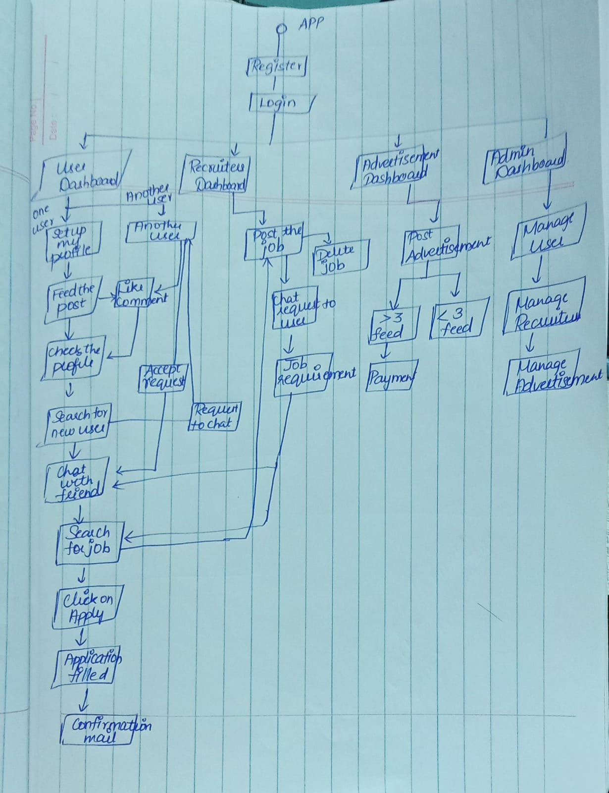

6. Application Modules:

6.1 User Management Module:

**User Registration:**

Allows users to create a new account by providing necessary information, such as name, email, and password.

**User Authentication:**

Implements secure login processes, verifying user identities through credentials. Commonly employs OAuth 2.0 for authentication.

**Profile Creation and Editing:**

Enables users to create and edit their professional profiles, including details like education, work experience, skills, and endorsements.

**Connection Management:**

Facilitates the process of connecting with other users, managing connection requests, and building a professional network.

**Security Measures:**

Implements measures such as password hashing, account lockouts, and security questions to enhance user account security.

**Privacy Setting:**

Allows users to customize privacy settings, determining the visibility of their profile, connections, and activities on the platform.

**Account Deactivation and Deletion:**

Allows users to temporarily deactivate or permanently delete their accounts, with appropriate confirmation and recovery processes.

**Notification Preferences:**

Enables users to customize the types and frequency of notifications they receive, ensuring a personalized experience.

**User Analytics:**

Tracks user interactions within the platform to provide insights into user behaviour, helping enhance the user experience.

**Access Controls:**

Manages access permissions for different user roles and functionalities within the app, ensuring secure and controlled access to features.

* 1. Content Management Module:

**Content Creation:**

Allows users to create diverse types of content, including text posts, articles, images, and videos, to share their professional insights, experiences, and updates.

**Content Editing and Formatting:**

Provides tools for users to edit and format their content, ensuring a polished and professional appearance before publication.

**Content Sharing:**

Enables users to share content on their profiles, in groups, and with their network to increase visibility and engagement.

**Visibility Settings:**

Allows users to customize the visibility of their content, choosing whether it's public, visible to connections only, or shared with specific groups.

**Engagement Metrics:**

Tracks engagement metrics such as likes, comments, and shares to provide users with insights into the impact and reach of their content.

**Hashtags and Mentions:**

Supports the use of hashtags to categorize and discover content, as well as mentions to tag and notify specific users or entities within posts.

**Content Recommendations:**

Utilizes algorithms to suggest relevant content to users based on their interests, connections, and professional activities.

**Media Upload and Embedding:**

Allows users to upload and embed multimedia content, such as images, videos, and documents, enhancing the richness of shared content.

**Content Moderation:**

Implements measures to moderate and manage content to ensure it complies with community guidelines and standards.

**Content Discovery:**

Facilitates content discovery through personalized feeds, trending topics, and recommendations, helping users stay informed and engaged.

**Real-time Updates:**

Provides real-time updates and notifications to users when their connections post new content or engage with their posts.

**Analytics and Insights:**

Offers users analytics on the performance of their content, helping them understand audience engagement and refine their content strategy.

* 1. Social Interaction Module:

**Connection Requests:**

Allows users to send and receive connection requests to establish professional relationships with others on the platform.

**Messaging:**

Enables real-time one-on-one and group messaging between connections, supporting professional communication and networking.

**Endorsements and Recommendations:**

Permits users to endorse skills and provide written recommendations for their connections, enhancing professional credibility.

**Likes and Comments:**

Allows users to express appreciation for content through likes and engage in discussions by leaving comments on posts and articles.

**Group Interactions:**

Facilitates participation in professional groups where users can share insights, ask questions, and connect with like-minded professionals.

**Event Participation:**

Supports interactions related to professional events, including discussions, networking opportunities, and sharing updates before, during, and after events.

**News Feed Interactions:**

Encourages engagement with the news feed, allowing users to like, comment, and share content, fostering a sense of community.

**Profile Views and Notifications:**

Notifies users about who viewed their profiles, encouraging reciprocal connections and engagement.

**Networking Suggestions:**

Provides suggestions for potential connections based on shared connections, industries, or interests, fostering new professional relationships.

**Message and Connection Requests Filtering:**

Allows users to filter and manage incoming messages and connection requests, providing control over their communication preferences.

**Notification Settings:**

Enables users to customize notification preferences, ensuring they stay informed about important interactions while managing notification frequency.

**Privacy Controls:**

Includes privacy settings to manage the visibility of profile information and control who can send connection requests or messages.

* 1. Messaging Module:

**Access Messaging:**

Look for the messaging icon, usually represented by a speech bubble or an envelope, depending on the version of the app.

**Compose a Message:**

Tap on the messaging icon to access your inbox. To start a new conversation, tap on the "+" or "Compose" button. Enter the recipient's name in the "To" field.

**Send Messages:**

Type your message in the text box. You can also send attachments, such as photos or documents, if needed. Tap the send button to deliver your message.

**Manage Conversations:**

Your messages will be organized into conversations with each contact. You can manage conversations, archive them, or delete them as needed.

* 1. Search and Discovery Module:

**Perform a Search:**

Tap on the search bar to enter keywords, names, or phrases related to what you are looking for. As you type, LinkedIn will provide auto-suggestions based on your input.

**Filter and Refine Results:**

After entering your search query, you can use filters to narrow down the results. Filters may include people, jobs, companies, groups, and more. Filters help you find specific types of content or connections within the LinkedIn network.

**Explore Content:**

In the "Discover" section or your homepage feed, you can find content recommended for you based on your profile, connections, and interests. LinkedIn's algorithm suggests posts, articles, and updates that align with your professional interests.

**Connect with People:**

When you find a person or professional, you'd like to connect with, you can send them a connection request directly from their profile.

**Company and Job Searches:**

Use the search bar to find companies or job opportunities. Explore company profiles to learn more about their employees, updates, and open positions.

**Follow and Engage:**

You can follow companies, influencers, and thought leaders to stay updated on their latest posts and activities.

7. Future Enhancements:

7.1 Technology Upgrades:

It will update its UI/UX for better navigation. Video integration is a focus, improving hosting and streaming features. Security measures will consistently update to protect user data. Networking tools and learning features are refined to facilitate professional connections and skill development.

7.2 Scalability Improvements:

It will invest in scalable infrastructure to handle increasing user traffic and data. This could involve optimizing database systems, adopting cloud services for flexibility, and implementing load balancing strategies. Enhanced content delivery networks (CDNs) may improve global access speeds. Additionally, scalable architectures could support the platform's growth and ensure a seamless experience for users.

8.Conclusion:

In conclusion, it continues to evolve with a focus on user experience, scalability, and innovative features. Ongoing investments in scalable infrastructure, including optimized database systems and cloud services, ensure the platform can handle increasing user traffic and data demands. It wants to maintain a commitment to networking, professional development, and security, the app remains a vital tool for professionals worldwide. Regular performance monitoring and strategic adjustments underscore dedication to providing a robust and scalable platform for its diverse user base.